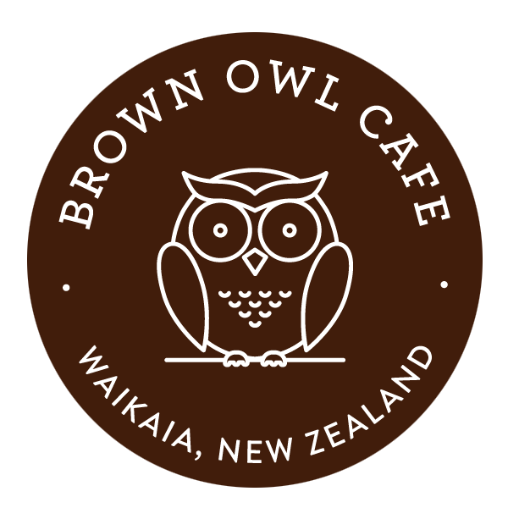
brown owl café menu
PLEASE ORDER AND PAY FOR MEALS AT MAIN COUNTER
- ALL DAY BREAKFAST $22.50
Streaky bacon, sausages, mushrooms, eggs, tomato, hash browns and served with white or brown toast, tomato sauce and relish. Add $4: baked beans/spaghetti

- HOT CAKE Stack $15.00
Pancakes, caramelized banana, streaky bacon, served with hot maple syrup

- EGGS BENNE $18.50
Streaky bacon and poached eggs served on rustic sourdough toast with hollandaise sauce and lemon avocado

- eGGS ON tOasT $11.00
Two eggs (poached, fried or scrambled), served with white or brown toast. Add $4: two sausages or three rashes bacon or baked beans/spaghetti

- OMELETE $12.00
With bacon and cheese. Extra fillings $2 each – red onion, mushroom or tomato

- Pie, chips & gravy $11.50
Pie of your choice with chips and gravy

- chicken tenders, salad & chips $16.50
Your choice of either two chicken breast tenders or four chicken tenders served with salad of the day and chips, accompanied with sweet chilli sauce

- B.L.T $16.50
Streaky bacon, lettuce, tomato with tomato relish and homemade mayo served with Criss cut chips and Sweet Chilli sauce, on white or brown toast

- Fish BASKET and chips $18.50
1 Dory, 1 Flake, 3 fish bites, crab stick, 2 squid rings and chips, served with aioli, tomato sauce and lemon. Add: five crumbed prawns $4.50 or two prawn twisters $5

- burgers $16.50
Chicken – with cheese, tomato, pineapple, lettuce with capsicum apricot sauce, beetroot relish and mayo
Beef – with cheese, tomato/beetroot relish, bacon, tomato, onion, egg, lettuce and mayo
Fish – with cheese, tomato, lettuce, onion, bacon, mayo and aioli
Bacon & Egg – with two eggs, bacon, onion, cheese, tomato, lettuce, tomato/beetroot relish and mayo
*All burgers served with Criss cut chips and Sweet Chilli sauce

- SALAD OF THE DAY $7.00
A bowl of delicious fresh salad. Add roast beef (2) or corned beef (2) for an extra $2. Served with condiments

- corn fritter stack $17.50
Corn fritters served with streaky bacon and sweet capsicum sauce, sour cream and side salad of the day

- toasted sandwiches $7.50
Your choice of white or brown bread with 3 fillings: smoked chicken, bacon, ham, cheese, tomato, mushrooms, pineapple, onion, egg or let us know what you’d like?

- wedges/CRISS CUTS $15.00
Served with crispy bacon, sour cream and sweet chilli sauce

- Gold Pan of HOT CHIPS $8.00
Served with tomato sauce, aioli or gravy

- children’s meals $7.50

- 4 Chicken nuggets or 2 chicken tenders and chips
- 3 Fish bites and chips
- 3 Mini hot dog and chips

*all served with sauce of choice

