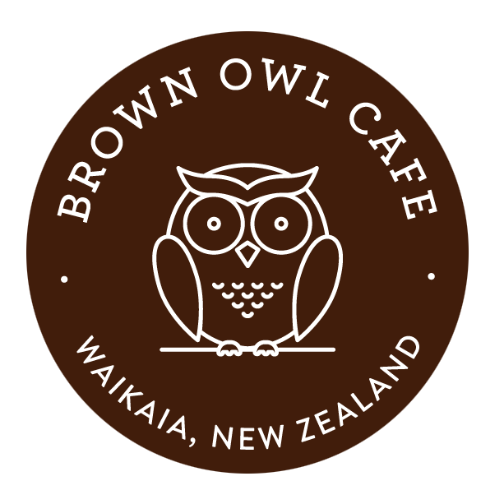
brown owl café menu
PLEASE ORDER AND PAY FOR MEALS AT MAIN COUNTER
Gluten Free options available, please ask the staff for options

- ALL DAY BREAKFAST $24.50
Streaky bacon, sausage, eggs, tomato, hash browns served with tomato sauce and relish
Extras: mushrooms, baked beans, spaghetti

- blue cod and chips $14
Served with aioli and lemon

- HOT CAKE Stack $16.00
Pancakes, banana, streaky bacon, served with hot maple syrup

- EGGS BENNE $20.50
Streaky bacon and poached eggs served on rustic sourdough toast with hollandaise sauce and lemon avocado

- eGGS ON tOasT $12.00
Two eggs (poached, fried or scrambled), served with white or brown toast. Extras: sausages, bacon, baked beans/spaghetti

- OMELETE $15.00
With bacon and cheese. Add extra fillings $2 each – red onion, mushroom or tomato

- B.L.T $18.50
Streaky bacon, lettuce, tomato with tomato relish and homemade mayo served with sidewinder chips or criss cut chips and sweet chilli sauce

- cajun wing dings & kumara chips $16.50
Four chicken wing dings accompanied with sweet chilli sauce

- wedges/CRISS CUTS/CHICKEN WEDGES $15.00
Served with crispy bacon, sour cream and sweet chilli sauce

- CHICKEN DIPPERS & CRISS CUT CHIPS $14.50
Five dippers accompanied with sweet chilli/tomato sauce

- soup OF THE DAY $9.50
Served with a mini garlic roll

- HOT CHIPs: GOLD PAN $9 OR WIRE BASKET $5
Served with tomato sauce, aioli or gravy

CHILDREN’S MEALS ON REQUEST

May change due to unavailability

